Community Project Assistance Fund (CPAF)
2025-2026 CPAF Grant Application Form

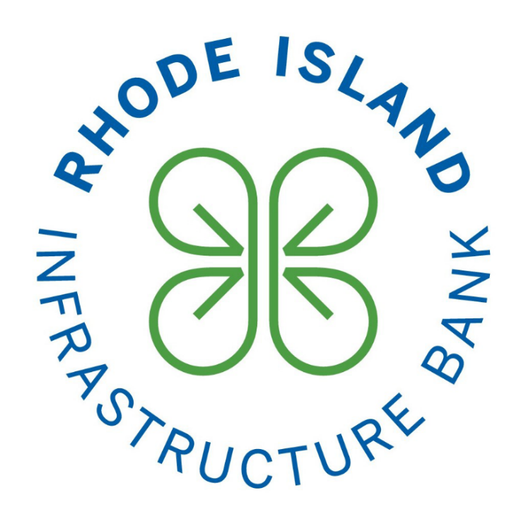

Project Title (6 words max): Insert Project Title
Municipality: Insert Municipality

Points of Contact & Basic Project Information:
Point of Contact Name: Insert name
Point of Contact Email: Insert email
Point of Contact Phone Number: Insert phone number
Point of Contact Department: Insert department
Mailing Address: Insert address

Will the Point of Contact also serve as the Project Manager?
☐ Yes ☐ No

If not, please provide the following information, otherwise leave blank:

Project Manager Name: Insert name
Project Manager Email: Insert email
Project Manager Phone Number: Insert phone number
Project Manager Department: Insert department

Project Type (Select all that apply):
☐ Design/Engineering/Permitting Work
☐ Produce a Study or Plan (feasibility study, needs assessment, strategic plan, etc.)
☐ Other, please specify:
Is the applicant intending to use this grant as a match for a Federal or State grant?
☐ Yes ☐ No

Project Budget:
Requested Grant Amount Here: Insert dollar amount

Project Overview
- Project Description & Scope of Work
What is the project scope, how will it be completed, and by whom?
Insert response here.

- Project Purpose & Benefits
How will this project help to address community challenges/vulnerabilities to improve community resiliency, stormwater management, and/or enhance public infrastructure?
Insert response here.

What benefits will the project deliver? Who will benefit? Will the project deliver multiple co-benefits? (ex. resiliency, environmental, economic development, quality of life, etc.)
Insert response here.

- Timeline & Project Tasks
When will the project start and finish, including key milestones? Please provide a list of key project tasks. Please note that all CPAF projects MUST be completed with 18 months of a grant agreement being executed with the Infrastructure Bank.
Task 1: insert task name and anticipated completion date
Task 2:
Task 3:
Add additional tasks as needed

- Budget
How will the requested grant funds be used? Aside from the requested grant funds, do you need to acquire additional capital to complete the project?
Insert response here.

Please complete the table below:
Use of Funds | Grant Amount
Contractual Expenses for Design/Engineering/Permitting
Contractual Expenses for a Study/Plan
Other (please specify)
Total: | $
The maximum amount which can be requested for one or more projects per municipality is $50,000.

Authorization of Grant Proposal Submission

_________________________________________ ________________________
Signature of Chief Municipal Officer Date

________________________________________
Name and Title

